# NWEG5122 ICE 07 SOLUTION

LAN -LOCAL AREA NETWORK

A LAN is a network of interconneccted devices in a limited geograpraphical area,these devices have a common line of communication wirelessly or using an ethernet cable.This type of network is very reliable and can be used on a range of devices.Usually used for areas such as homes ,offices and small buildings.

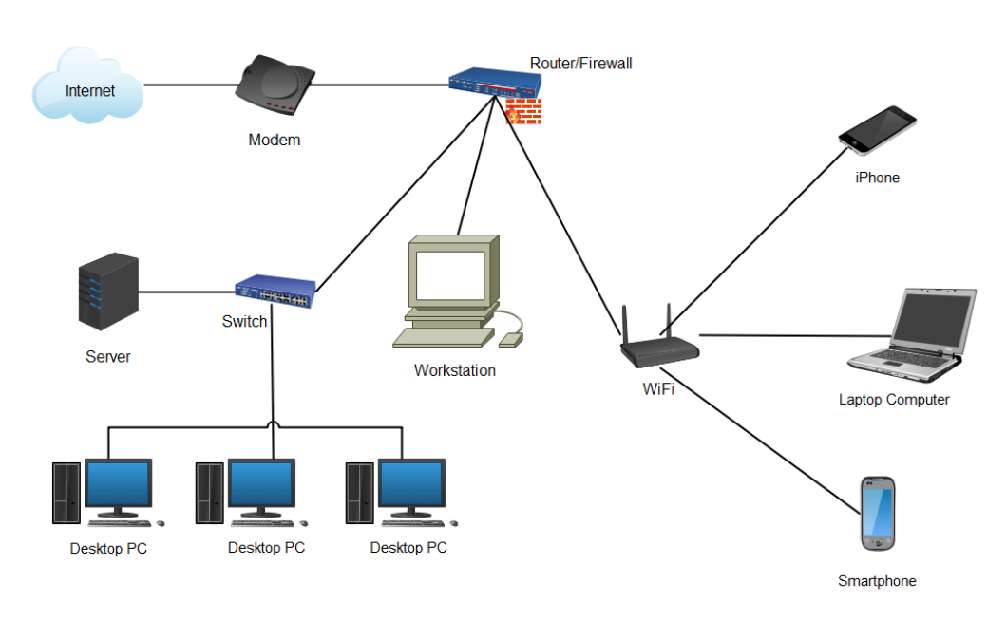

Figure :Local Area Network Diagram Lan Diagram Complete Guide: EdrawMax (no date) Edrawsoft. Available at: https://www.edrawsoft.com/lan-diagrams.html (Accessed: 16 October 2023).

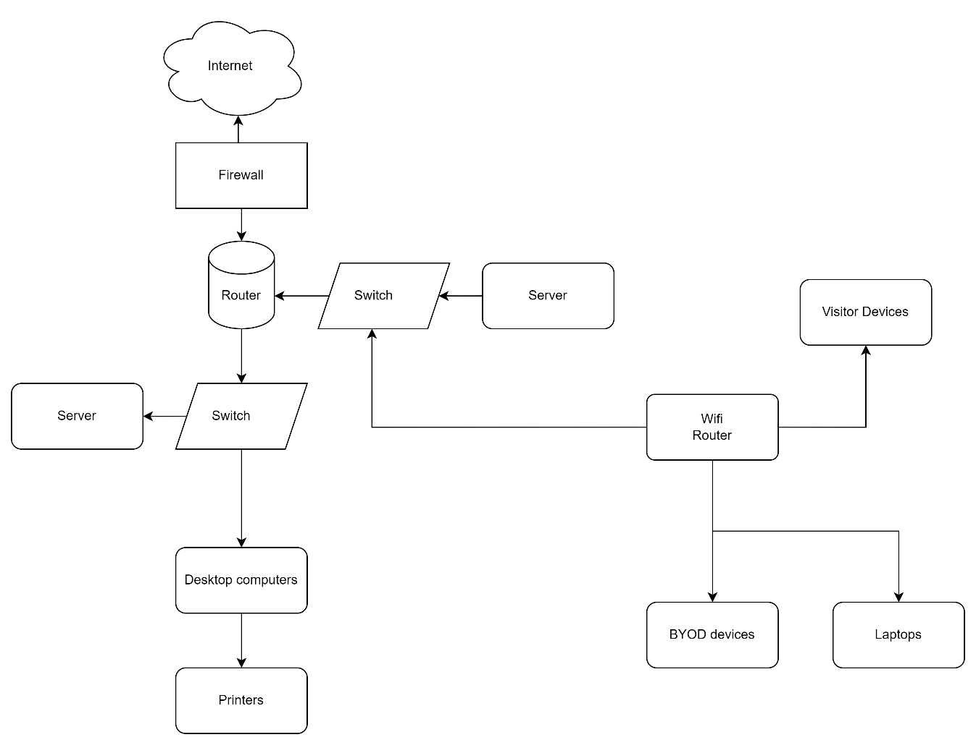

Figure :LAN diagram of Mr Khoza's network

WAN -WIDE AREA NETWORK

A wide area network is a private network that interconnects a group of Lans, connecting devices over a large geographical area compared to LANs. VPNs assist in the connectivity in WANs and increase security of the data communicated between networks.

Figure 3:WAN in Computer Networks Wan Diagram Complete Guide: EdrawMax (no date) Edrawsoft. Available at: https://www.edrawsoft.com/wan-diagrams.html (Accessed: 16 October 2023).

Figure :WAN diagram of Mr Mkhize's WAN

# REFERENCES

Local Area Network (LAN). computer and network examples: Wide Area Network (WAN) topology. computer and network examples: Network Diagram Software. LAN network diagrams. Physical Office Network Diagrams: Local Area Network Diagram (no date) https://www.conceptdraw.com. Available at: https://www.conceptdraw.com/examples/local-area-network-diagram (Accessed: 16 October 2023).

Odessa, C. (no date) Network diagram, MyDraw. Available at: https://www.mydraw.com/diagrams-network-diagram (Accessed: 16 October 2023).

Serpanos, D and Wolf, T. 2011. Architecture of Network Systems. (1st ed). Burlington: Elsevier. ISBN: 9780123744944 Available on EBSCOhost at http://search.ebscohost.com.ezproxy.iielearn.ac.za/login.aspx?direct=tr ue&db=nlebk&AN=353481&site=ehost-live [Accessed: 27 July 2023]

Froehlich, A. and Hwang, D. (2021) What is a lan? - definition from whatis.com, Networking. Available at: https://www.techtarget.com/searchnetworking/definition/local-area-network-LAN (Accessed: 16 October 2023).

Scarpati, J. (2023) What is Wan?, Networking. Available at: https://www.techtarget.com/searchnetworking/definition/WAN-wide-area-network (Accessed: 16 October 2023).